Conceptual Bootstrapping

# Rationale

Various arguments have been made that iconicity has important implications for the general acquisition of language. The most recent and well-developed of those is the Sound-Symbolic Bootstrapping Hypothesis, by Kita & Imai (2014).

However, the sound-symbolic bootstrapping hypothesis isn't really a fully fleshed-out theory of how iconicity bootstraps acquisition, in my PhD Dissertation I break this apart further, separating *Conceptual* and *Referential* bootstrapping, and suggested that the SSBH is mostly about referential bootstrapping.

Bootstrapping theories in general have a lot of problems- it's not always clear what is meant by bootstrapping, which I take to be a non-linear emergent process wherein subsequent processes are only possible given initial inputs (bootstraps) that are not merely scaffolding, but that take an active role in producing output processes. Leaving that aside, however, bootstrapping and scaffolding processes require testing- the current state of the literature is an argument based on the temporal patterning of language acquisition (early language = iconic, late language = arbitrary, therefor early language => late language).

**In this document I aim to outline how we can explore at least one version of bootstrapping experimentally.**

## Types of Bootstrapping

### Referential Bootstrapping

*"The central idea of this hypothesis is that the natural connection between certain words and meanings endows language learners with the ability to establish reference, and that this general referential ability underpins the later ability to map arbitrary words to meanings (Perniss, Thompson, & Vigliocco, 2010). The referential bootstrapping hypothesis thus relies on motivatedness as a mechanism to explain how reference is established (Baldwin, 1993), and further suggests that referential bootstrapping in spoken language is analogous to the enhancement of referential establishment in gestural communication systems (Perlman, Dale, & Lupyan, 2015)."*

Below is Kita & Imai's formulation of the central idea of their SS bootstrapping hypothesis, which I think fits nicely as being considered referential bootstrapping

*"Sound symbolism may serve as an important bootstrapping mechanism for establishing referential insights for speech sounds. Although infants may start to associate words and referents as early as 6 months of age (Bergelson & Swingley, 2012), this process is initially slow and effortful. Reports in the literature show that, up to 13 months, infants are not so efficient in picking up the referent in preferential looking, but that at 14 months, they become qualitatively different and perform much better (Bergelson & Swingley, 2012; Werker et al., 1998). In other words, young infants need much more scaffolding to establish word referent associations than older infants. Sound symbolism may be a helping cue derived from a naturally endowed biological capacity to map speech sounds to perceptual properties"*

It's not entirely clear exactly what Kita + Imai mean by helping cue- there are at least two possibilities for what is going on, listed below:

#### Establishment of Reference

This would be what I would call the strongest version of referential disambiguation. It suggests that iconicity provides the ability for children to learn that sounds can refer to objects in the environment *at all*- i.e. because some form-meaning mappings are natural, they do not need to be learned, and children can appreciate, for example, that the word 'moo' refers to the sound a cow makes, which is quite similar.  
  
They can thus generalise from that type of iconic connection to other connections- learning for example that 'cow' is a word for cows despite the fact that it is not an iconic word (or at least less iconic than moo).

**The unfortunate thing about this version of referential bootstrapping is that it does not seem likely that we could explore it experimentally with adult human participants** (because they understand that sounds can refer to objects).

There is one *small* possibility for exploring this experimentally- perhaps participants could learn that a feature not normally relevant for their language (e.g. tone for non-tonal speakers) is meaning bearing more easily when given examples where it is leveraged iconically (and perhaps subsequently learn tone differences easier than controls).

#### Referential disambiguation

The second type of referential bootstrapping refers to disambiguation- in this case iconicity helps disambiguate *what specifically* is being referred to in a scene- this is what researchers are referring to when they suggest that iconicity makes up for the poverty of ostension in verb learning, for example.  
  
There is some literature in this area, but it's definitely an area where there could be lots of potential productive work in the future.

### Conceptual Bootstrapping

The second type of bootstrapping that I lay out in my dissertation is *Conceptual bootstrapping*, which I suggest might be a counterpart to referential bootstrapping that can be based on *systematic* associations between sets of words and sets of meanings (which may or may not be iconic). Again this can be split into the same two types of theories as can referential bootstrapping.

The text of my dissertation reads as follows:

*"Here, I propose that if systematicity also enhances later learnability, it may do so through a process that bootstraps the acquisition or transparency of concepts and categories. I refer to this possibility as conceptual bootstrapping, and suggest that systematic associations might make the structure of the underlying categories that they reflect more apparent, or allow for the establishment of categories that are increasingly obscure."*

#### Establishment of concepts and categories

This is the exact parallel to referential establishment- the idea is that systematic associations can allow children to learn about the existence of natural kinds- in a case, for example, where all edible plants had the same ending "-um", a learner might have their understanding of the category enhanced by the fact that the shared feature of meaning aligns with a shared feature of phonology.

Again, this is difficult to test with adults- who already have a robust system of concepts and categories.

#### Conceptual disambiguation

The second possibility, and the one I hope to focus on testing here, is that systematicity (perhaps in combination with iconicity) can help disambiguate which categories are relevant or what features are relevant for separating those categories. Although adult learners understand categories generally, it is possible to make use of experimental stimuli that are separable into categories but that do not have existing linguistic labels disambiguating between the two.

## What we already know

Experimental stimuli like the "yufo" (Gauthier & Tarr, 1997), where the distinction between the two types of images is not immediately apparent, even to adult learners.

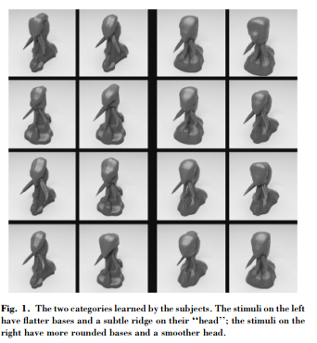

Lupyan et al (2007) found that simply by having names, the category distinction between the two types of Yufos was made more salient and the categories were learned more easily.

The labels in this experiment were "leebish" vs. "grecious" (counterbalanced between participants)

**Training**: Presented with pairs of images and labels and have to either approach or run away (one group dangerous- counterbalanced). Given feedback after each trial.  
  
**Testing**: Presented only with images and no label, and no feedback

**Results**:

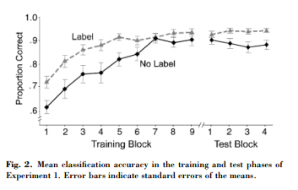

So, you can see that when they have the label (during training) they are better at doing the task, but that's also true at testing when the label is no longer present.

Following this, **Lupyan & Casasanto (2014)** conducted a similar experiment, but where the assocaition between the category label and the meanings was iconic, rather than conventional

The labels in this experiment were "foove" and 'crelch'

**Experiment 1- Attribution Task-**

First expeirment had the words foove and crelch rated by a number of participants for a number of attributes:

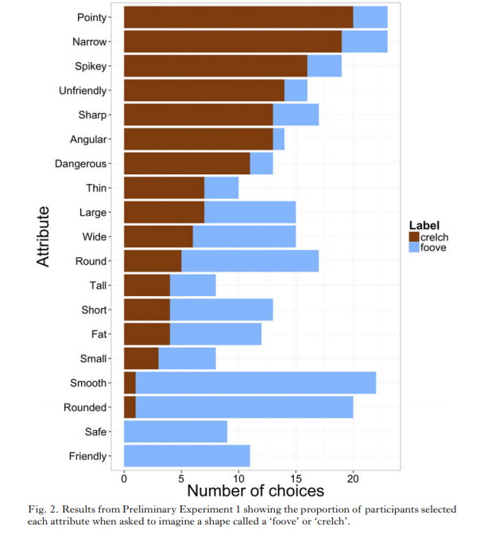

**Experiment 2- Sorting Task**

Participants in *conventional label* condition were presented with between 4 and 12 Yufos and asked to sort them into either 'round' or 'pointy' species. Participants in *nonce-labels* condition asked to sort into 'foove' or 'crelch' species.

*"To test the hypothesis that the labels aff ected which aliens participants chose, we calculated the likelihood of clicking on each item as a function of its species and the congruency between the label prompt and alien species. Clicks on the round-headed aliens when prompted by ‘round’ or ‘foove’ and clicks on the pointy-headed aliens when prompted by ‘crelch’ or ‘pointy’ were classifi ed as congruent; the rest were incongruent. Of the selected aliens, 67% were congruent with the label. Overall, the likelihood of clicking on aliens congruent or incongruent with the label prompt was 47% and 23%, respectively ( z = 10.96, p .0001) (mixed-eff ect model using congruency as meaningless words−meaningful categorization 9 a predictor). The congruency eff ect was much stronger in the conventionallabel condition (75% of selected items were congruent) compared to the nonce-label condition (59%). This congruency-by-label-type interaction was highly reliable ( z = 5.37, p .0005). Nevertheless, participants were still signifi cantly more likely to choose round-headed aliens when asked to choose ‘fooves’ and pointy-headed aliens when asked to choose ‘crelches’ ( z = 4.10, p .0005). The results of these studies show that nonce labels guide not only selections of verbally described visual attributes (Preliminary Study 1), but also guide selections of complex visual stimuli that embody those visual properties (Preliminary Study 2)."*

**Experiment 3- Effect of nonce labels on category learning**

**Conditions-**   
No Label  
Congruent Nonce label (foove vs. crelch)  
Incongruent Nonce Label  
Congruent Conventional (round vs. (grooved or pointy)   
Incongruent conventional

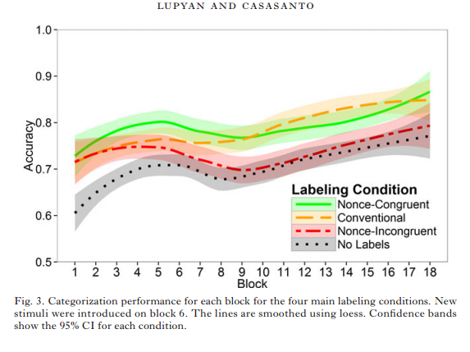

## The Experimental Question

So, the results of these studies show us that basic level labels can facilitate the learning of categories/alignment on the splitting of objects into categories- this is true of both iconic and conventional labels (and debatably of incongruent labels).

In a sense, this work *could* have been framed as having to do with conceptual bootstrapping- having labels helps acquire the acquisition of understanding about what features are relevant for separating objects into distinct categories. In this case, the stimuli might have a natural separation, but the use of labels might make it easier to see where that separation is, and thus facilitate the process of 'carving nature at its joints'.

**What I am interested in is whether having *individual* labels/names can facilitate this process**

# The Experiment

Here we are interested in exploring the effect of individual labels on categorisation- specifically, whether having labels that are systematic can influence how experimental participants sort the Yufo stimuli into their two types.

## Design

The basic experimental design is very similar to previous designs used by Lupyan & Casasanto, and is a task where participants are given training where they learn to associated single Yufo stimuli with auditory (and orthographic?) labels, and are then tested, sans labels, on how they sort the stimuli (sans labels) into two categories.  
  
Stimuli

#### Images

Stimuli are potentially difficult.  
  
I was originally of a mind to use the Yufo stimuli, because there is a history of using them, but there maybe better stimuli out there. Whatever set we use, the stimuli need to have a few features:  
  
1) There needs to be at least one recognizable division in the set, one that might not be immediately apparent to participants, but that they could learn

2) Whatever the difference is between subdivisions, it should be amenable to an iconic mapping

#### Labels

Labels are fairly simple, especially if we stick to a set of stimuli that can be mapped to the Bouba-kiki effect, for which I have scads of stimuli

### Training

Training should , I believe, be pretty much identical to previous designs- so participants see a single word and image.  
  
However I don't know if we want to go with the approach/move away design- in this case we aren't trying to explicitly teach them a category distinction (necessarily) - instead we are trying to give labels that make it obvious that there *is* a category distinction, but maybe no feedback about the actual underlying category distinction- thoughts?

### Testing

Testing might explicitly query learning- can participants actually learn to individuate the Yufo stimuli? or do they mostly make within-category errors.

Strictly speaking, I am not sure whether this step is necessary or not- but it might tell us some interesting things when we compare the conditions to one another (see below)  
  
Sorting

This is the final task of the Experiment, where participants are tasked with sorting the full set (or some subset?) of the stimuli into two groups (with no labels shown)

### Conditions

A number of experimental conditions are possible- originally I wanted only to mirror the design of my Motivated vs. Conventional Systematicity work, so we would have: iconic + systematic, conventional + systematic, counter-iconic + systematic

But a more complete list of possible conditions would be this  
  
**1- Iconic + Systematic**

**2- Countericonic + Systematic**

**3- Conventional + Systematic (counterbalanced)**

**4- Arbitrary (fully arbitrary)**

**5- Arbitrary (half-half)**

**1 - No Names**

The No Names condition of the experiment (6) might give us what we call our "neutral" sort of the stimuli into categories- so how foovey/crelchy each of the stimuli is- in an ideal world we'd actually want the neutral sort to not be spectacularly well aligned (either between-participants or to our expectations), because we want room for participants to improve. There is some problem with the no names condition as an actual condition though- it doesn't allow us to have a testing phase (there is nothing to test) other than sorting. So we might actually want two no-name phases- one where they have no experience with the stimuli, and one where they go through training/familiarisation (to see if mere exposure influences sorting).

**2- Arbitrary (fully)**

In this condition of the experiment, names are selected from a very large pool and are unrelated to each other both within and between categories. The idea of this condition is to see whether learning associations at the base (with nothing either iconic or systematic going on) influences categorisation- it might be the case for example that bare exposure (no names) is insufficient to guide categorisation, but that trying to remember individual features makes underlying categories more obvious.

**3- Iconic + Systematic**

Here all fooves have 'foove-like' names (e.g. bouba names) and all crelches have kiki names. We would expect in this condition that participants would sort much more consistently compared to each other (and to our expectations). However, because label features and perceptual features are redundant in this case (at least so we think) there is no way to know whether the sorting is biased by perception or by systematicity- so you need to compare this to other conditions to know what is going on.

**4- Anti-Iconic + Systematic**

I'm not sure this is required for this experimental design- but it's something to think about at least.

**5- Conventionally Systematic**

Here you have labels that are not iconic (all using fricatives in Nielsen et al., 2016- and we'd likely follow that)- so there is nothing particularly 'crelch'-like on an individual word-meaning mapping level that should make the task easier, but there is still a systematic association going on that might aid categorisation of the meanings.

**6- Arbitrary (Half-half)**

How do we know that providing redundant labels is not only forcing participants to do the sorting based on the systematic associations of those labels (which would look like it unmasks category structure)? We need to compare to a language where there is a systematic split (half of all words are bouba-like, half are kiki like) but that split does not align to the perceptual differences. So half of the crelches have a crelch like word, and half have a foove-like word. In this case participants might sort based on either a) perceptual differences between stimuli or b) label systematicity, but the two would be incongruent with each other.

**7- No Image Categories**

This might not be an isolated condition, but might be a crossing with all other conditions- the idea is that you need one other test of how categorisation goes- a case where there actually isn't a sensible differentiation between two subtypes of meanings (or a less clear one)- so participants would, for example, be given all fooves- In this case we might predict that they would sort based on labels (if at all).

## Remaining Design Questions

## Possible Experiment Configurations